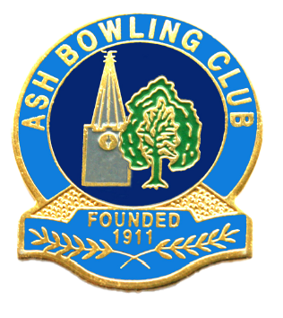

ASH BOWLING CLUB
TRAINING
PROGRAMME.

COMPILED BY THE CLUB COACHES:-
Phylis Castle Lead coach.
John Kirtley Club Captain
Judy Martin and Garry Huse.

Six Session Programme and Refresher Days For All Members.

Session 1.
Attire. Flat sole shoes, loose fitting garments.
Health and Safety. Getting on and off the Green.
Placement of equipment.
The Green. Explanation of the Green and its markers.
The Rink. Playing area.
Object of the Game.
Teams. Singles – Fours mixed teams. Rotation
Bias of the woods.
Placing the Mat. Stick and Measure.
The Jack. Delivering and setting.
Feedback.

Session 2.

Refresh of last session.
Selecting Woods. Size comfort and safety.
Placing the mat.
Delivering and setting the Jack.
Forehand delivery of woods.
Bias and delivery line.
Foot Placement.
Feedback.

Session 3.
Refresher of last session.
Delivering and setting the Jack.
Refresh forehand.
Back hand delivery.
Foot placement.
Target Time Horseshoe.
Sign off that you are content the member is competent and is no risk to the green, themselves or anyone else to allow individual practice of elements already undertaken.
(If this is not possible then annotate the members book with what needs further work and ensure this is followed up as a priority at the next session).
Feedback.

Session Four.
Full refresher on all aspects of training.
Mat.
Jack.
Forehand.
Backhand.
Reading the head Shot selection.
Competitive play.
Feedback.

Session 5.

Full refresh and individual needs.
Feedback.

Session 6.

Measuring shots.
Marking woods.
Live or Dead woods.
Shot count.
Declaration of shots.
Etiquette of the game and social areas.
Marking Singles Games, Competitions.
Long Measure.
Mat/Jack measure, short Jack.
Feedback.
Sign off member.

